AREA COUNCILLOR ADDRESS AREA COUNCILLOR PHONE#
CITY, STATE ZIP email address

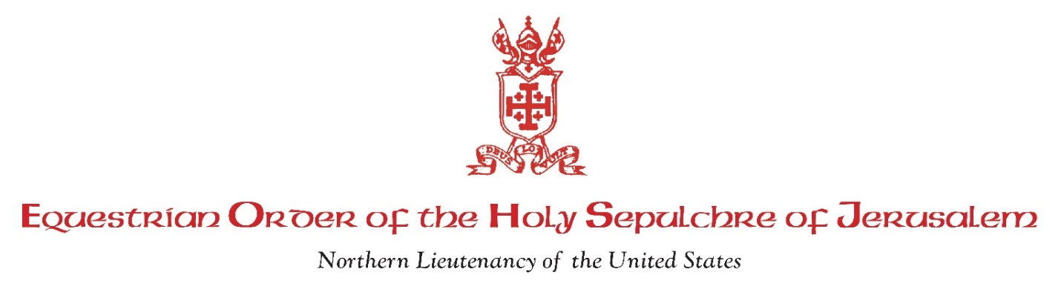
DATE
Most Reverend <BISHOP/ARCHBISHOP NAME>
ADDRESS
CITY, STATE ZIP

Your Excellency:
The following is a list of members from the Equestrian Order of the Holy Sepulchre of Jerusalem in our Area that are eligible for promotion in <CURRENT YEAR>:
<Insert current list of eligible members with current rank and promotion rank>
Sir John Smith, KHS to KCHS

According to our records, these candidates meet the qualifications for promotion (including annual meeting attendance and financial contributions). Additionally, we have enclosed a copy of each member’s Evidence of Subsequent Good Services performed after admission or last promotion. We have carefully reviewed the information submitted and believe that each of these candidates is worthy of promotion.
If after your review you also agree, we ask you to please send us your written approval of these candidates. One letter listing the names of these candidates that meet your approval for promotion is sufficient. We have included a sample letter for your convenience. While we ask that the letter is addressed to our Lieutenant, please mail the approval letter directly to us.
Upon receipt of your approval letter, we will proceed with the Order’s promotion approval process. Please call if you have any questions or comments.
Thank you for your assistance,

Sir <NAME> and Dame <NAME>
EOHSJ Area Councillors

