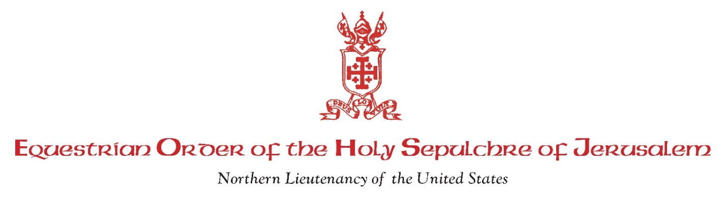
<Insert Date>
<Insert Father’s Name and Address>

Dear Father <Name>:
<Insert Nominee Name(s)>, members of <Insert Parish Name>, have been proposed for membership as a Knight and/or Dame in the Equestrian Order of the Holy Sepulchre of Jerusalem. A copy of the Duties and Responsibilities of the Knights and Dames of the Order is attached for your information.

As their pastor, would you kindly provide us with your confidential letter stating your approval that they are practicing Catholics, of unblemished moral reputation, and worthy to receive this Papal honor. In your letter to us, please provide some commentary and details related to the individual(s) involvement with regard to time, talent and works of charity.

If you give them a favorable recommendation, we will then also seek the approval of <Insert name of Archbishop/Bishop>.

Your letter should be addressed to our Lieutenant as follows:
H.E. <Insert Lieutenant’s Name>
Lieutenant, Northern Lieutenancy
Equestrian Order of the Holy Sepulchre
<Insert Lieutenancy Address>

Please return this letter directly to us at:
<Insert name and address>

Please keep this matter confidential. Call or email us if you have any questions. Thank you for helping us.

Sincerely,

Sir <Area Councillor> and Dame <Area Councillor>
Phone: <Insert Phone Numbers>
Email: <Insert Email Address>

