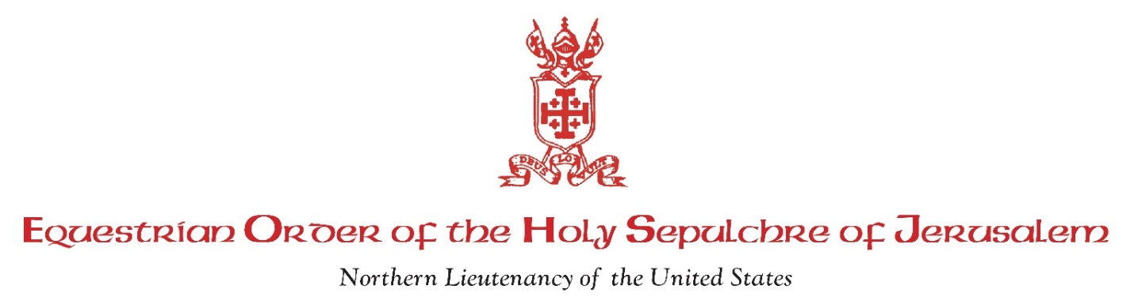
<Insert Date>
Dear <Insert Nominee(s) Name(s):

It is our honor and privilege to advise you that you have been recommended by His Excellency <Insert Archbishop/Bishop Name> and your pastor, <Insert Pastor Name>, to be nominated to the Papal title of Knight/Dame of the Equestrian Order of the Holy Sepulchre of Jerusalem. This honor comes to you as distinguished Catholic(s) of demonstrated fidelity and loyalty to the Church and your generosity with regards to your time and treasure in support of Church needs.

Enclosed is a descriptive brochure about our Northern Lieutenancy, as well as the Duties and Responsibilities of the Knights and Dames of the Holy Sepulchre of Jerusalem. You can also find detailed information about membership in the Order in the Orientation Handbook found on our website at www.eohsjnorthern.com.

The Order is an ecclesiastical Order, one of the oldest within the Church. Membership is the highest Papal award which can be conferred upon clergy and laity alike. The Holy See has assigned to the Order the Apostolate of helping to preserve an active Christian presence in the Holy Land. This we accomplish through our prayers and the spiritual formation of the Members, as well as through the material support given to the Latin Patriarch in Jerusalem.

Membership in the Order does not require frequent meetings and is not time consuming. There is an annual meeting of the Northern Lieutenancy of the United States each year. The Northern Lieutenancy is an eight-state region of which <name of this area> is a part. We also hold a meeting of the members in our area with <Bishop/Archbishop> of our diocese each year.

We are the Area Councillors for <Insert Area>, and it is our responsibility to notify nominees and prepare the information necessary to apply for membership. We would like the opportunity to sit down with you to discuss membership in the Order and answer your questions. Please call or email us as soon as possible to arrange a convenient time.

This letter should be considered confidential, although of course you may discuss it with your Pastor. We do ask the favor of your prompt reply if you choose to accept this invitation, so that we have sufficient time to prepare and forward your nomination to Rome for final approval.

Once again, our sincere congratulations for the high honor being extended to you. If there is further information you need or if you have any questions, please call or email us.

Sincerely,

Sir <Area Councillor> and Dame <Area Councillor>
Telephone: <Insert phone number>
Email: <Insert email address>

