<DATE>
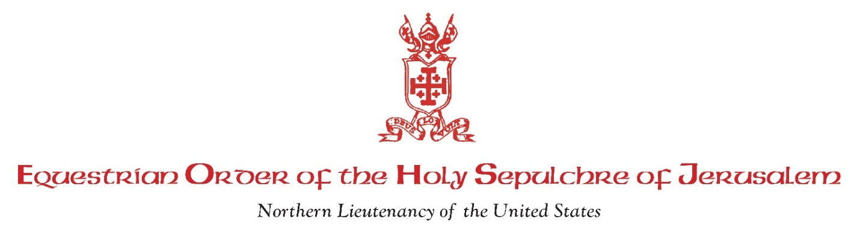
Membership Information Request
To complete the Membership Packet for submission to Rome for final approval, we need the following information for each nominee:
1. Certificate of Baptism with notations. (Original and one copy.) This should be requested from the parish where the baptism was performed. This is NOT the original Baptism Certificate given to you on your baptism. The Certificate of Baptism must be signed and dated no more than six months prior to the date that the Membership Packet is submitted.
2. Certificate of Full Communion. (Original and one copy). If you were not baptized in the Catholic Church but were baptized in a different Christian denomination, in addition to a Certificate of Baptism from your church of baptism, a Certificate of Full Communion should be requested from the parish where your confirmation into the Catholic Church was performed. The Certificate of Full Communion must be signed and dated no more than six months prior to the date that the Membership Packet is submitted.
3. Certificate of Marriage (Original and one copy.). If you are married, a Certificate of Marriage should be requested from the parish where your marriage was performed. This is NOT the original Marriage Certificate given to you at your wedding nor the civil marriage license. The Certificate of Marriage must be signed and dated no more than six months prior to the date that the Membership Packet is submitted.
4. Declaration of Nullity (Two copies.) If you are in a second marriage and your former spouse is still alive, two copies of the Declaration of Nullity of the prior marriage must also accompany the application packet. These do not have to be specifically certified because the Declaration itself will contain a special unique Protocol Number that allows independent verification of the proceedings.
5. Brief Curriculum Vitae (Two copies.)
6. Recommendation for Admission Form (Two copies.) You must complete and sign the back side of this form.
7. Honorarium Check. (Original and one copy.) A minimum Honorarium of <$AMOUNT> by check payable to Equestrian Order of the Holy Sepulchre of Jerusalem. This honorarium goes to Rome and is used to further the Order’s mission in the Holy Land. This contribution is tax deductible and includes your first year’s donation. After the first year, contributions in the amount of <$AMOUNT> are requested annually and are tax deductible.
Our Lieutenant will notify you when your membership has been accepted by the Order’s Grand Magisterium in Rome. At that time, he will also provide you with information on how to order your cape and beret or mantilla. Currently the approximate cost for a Knight is <$AMOUNT> and for a Dame <$AMOUNT>.
The meeting for the Investiture will begin with a mandatory Investee Orientation meeting on Friday, September <DATE, YEAR>. The Investiture <Date> is Sunday afternoon, September <DATE, YEAR>.

